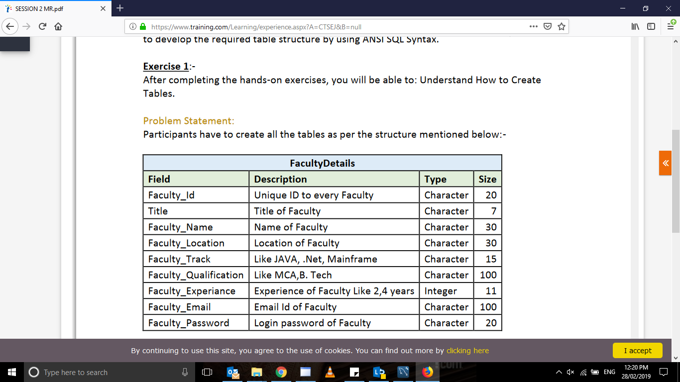

create table facultydetails

(

faculty_id varchar(10),

title varchar(20),

faculty_name varchar(40),

faculty_location varchar(50),

faculty_track varchar(20),

faculty_qualification varchar(10),

faculty_experience integer,

faculty_email varchar(30),

faculty_password varchar(20)

);

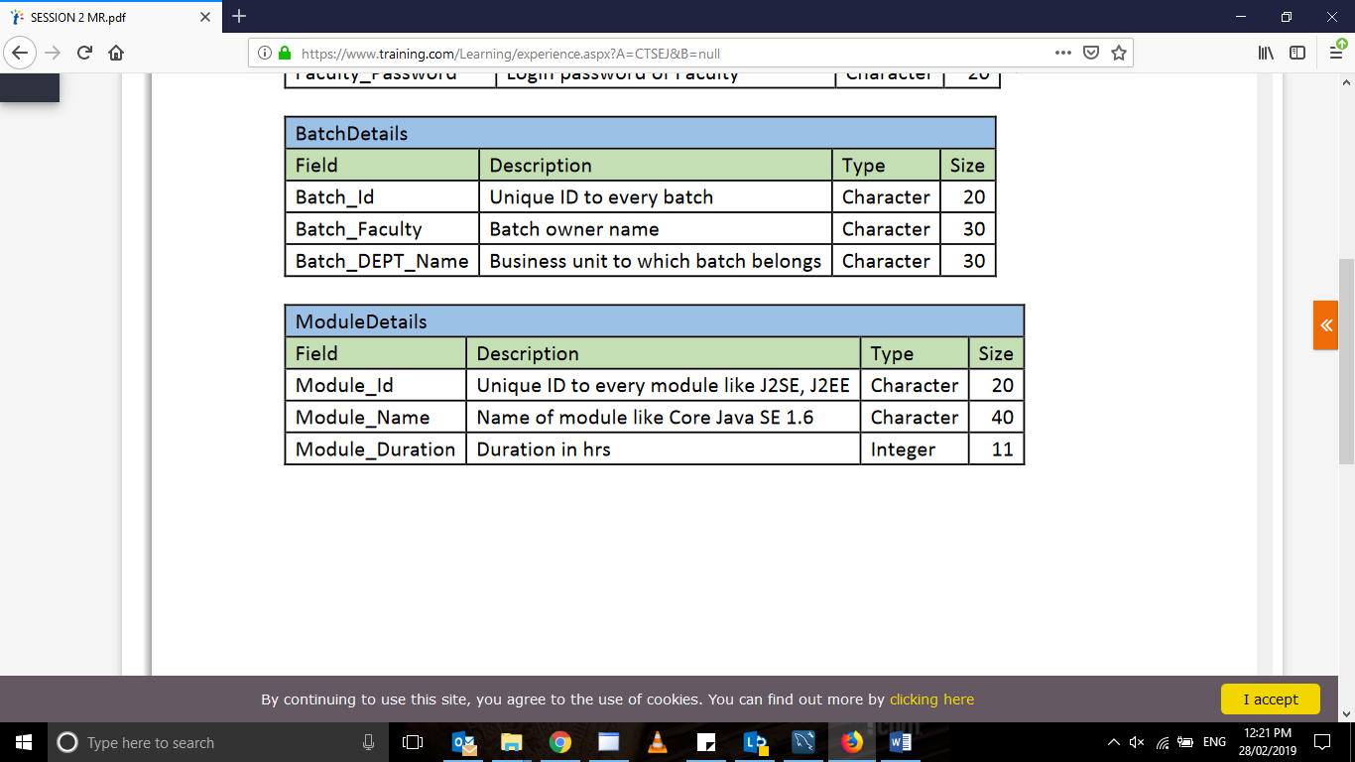

create table batchdetail

(

batch_id varchar(10),

batch_faculty varchar(20),

batch_dept_name varchar(40)

);

create table moduledetail

(

module_id varchar(10),

module_name varchar(20),

module_duration integer

);

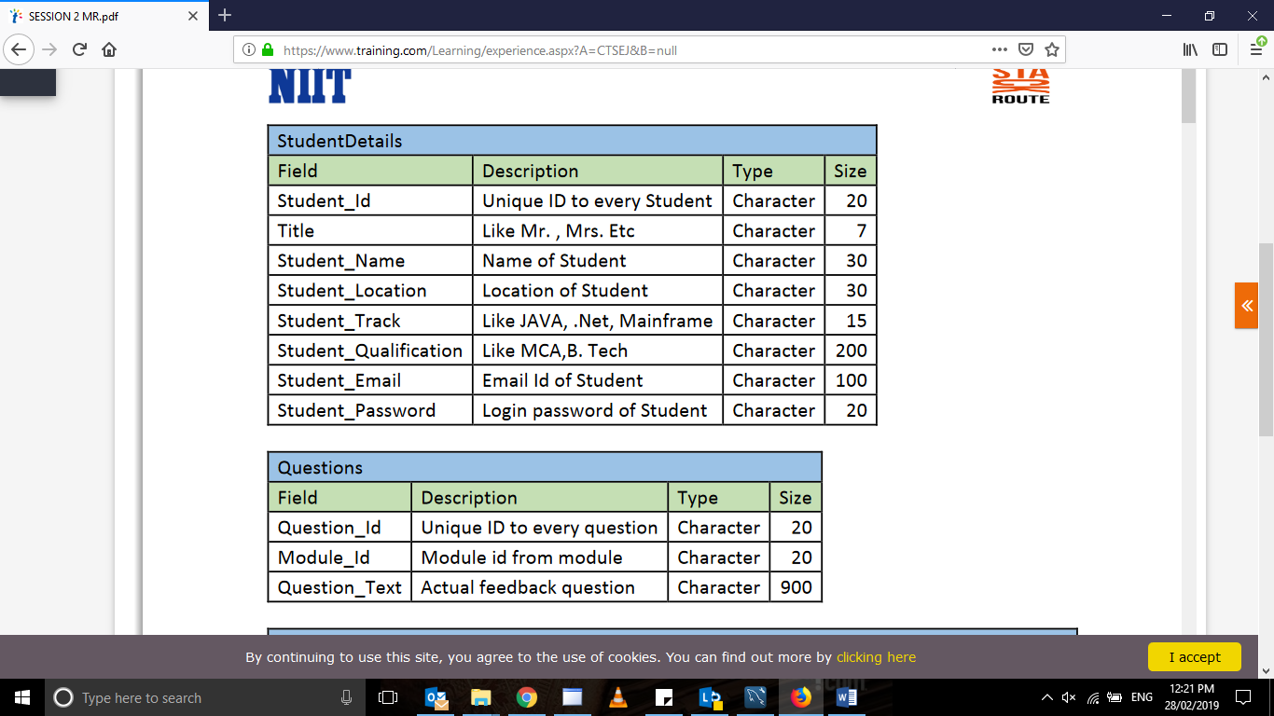

create table studentdetails

(

student_id varchar(10),

title varchar(20),

student_name varchar(40),

student_location varchar(50),

student_track varchar(20),

student_qualification varchar(10),

student_email varchar(30),

student_password varchar(20)

);

create table Questions

(

question_id varchar(10),

module_id varchar(20),

question_text varchar(40)

);

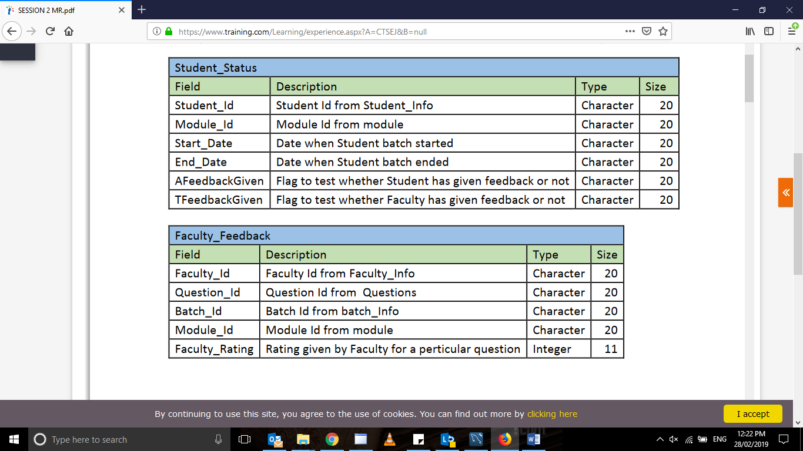

create table student_status

(

student_id varchar(10),

module_id varchar(20),

start_date varchar(40),

end_date varchar(40),

Afeedbackgiven varchar(40),

Tfeedbackgiven varchar(40)

);

create table faculty_feedback

(

faculty_id varchar(10),

question_id varchar(20),

batch_id varchar(40),

module_id varchar(40),

faculty_rating integer

);

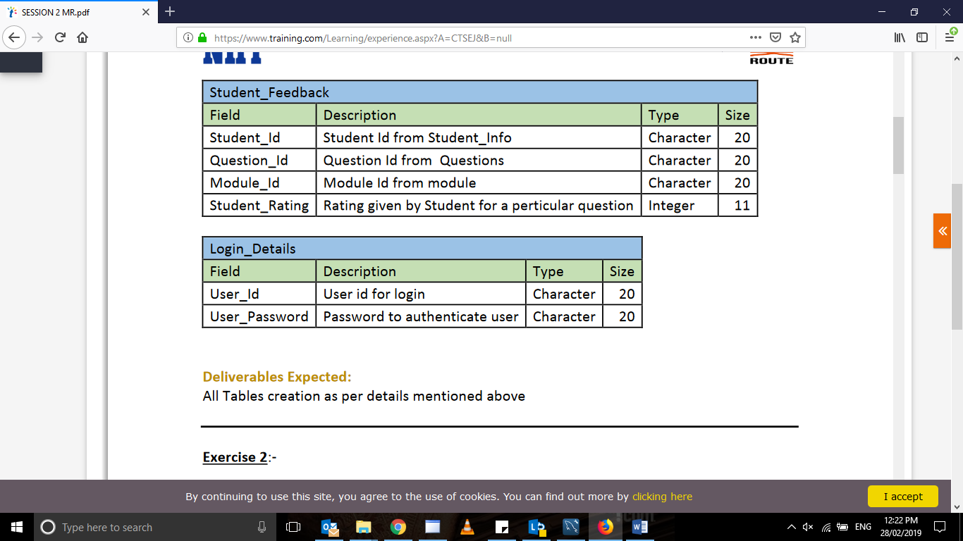

create table student_feedback

(

student_id varchar(10),

question_id varchar(20),

module_id varchar(40),

student_rating integer

);

create table login_details

(

user_id_id varchar(10),

user_password varchar(20)

);